1. Create a nonclusterd index for the enter_date column of the works_on table. Sixty percent of each index leaf page should be filled

CREATE NONCLUSTERED INDEX IX_work_on_EnterDate ON dbo.Work_on (enter_date) with (fillFactor = 60)

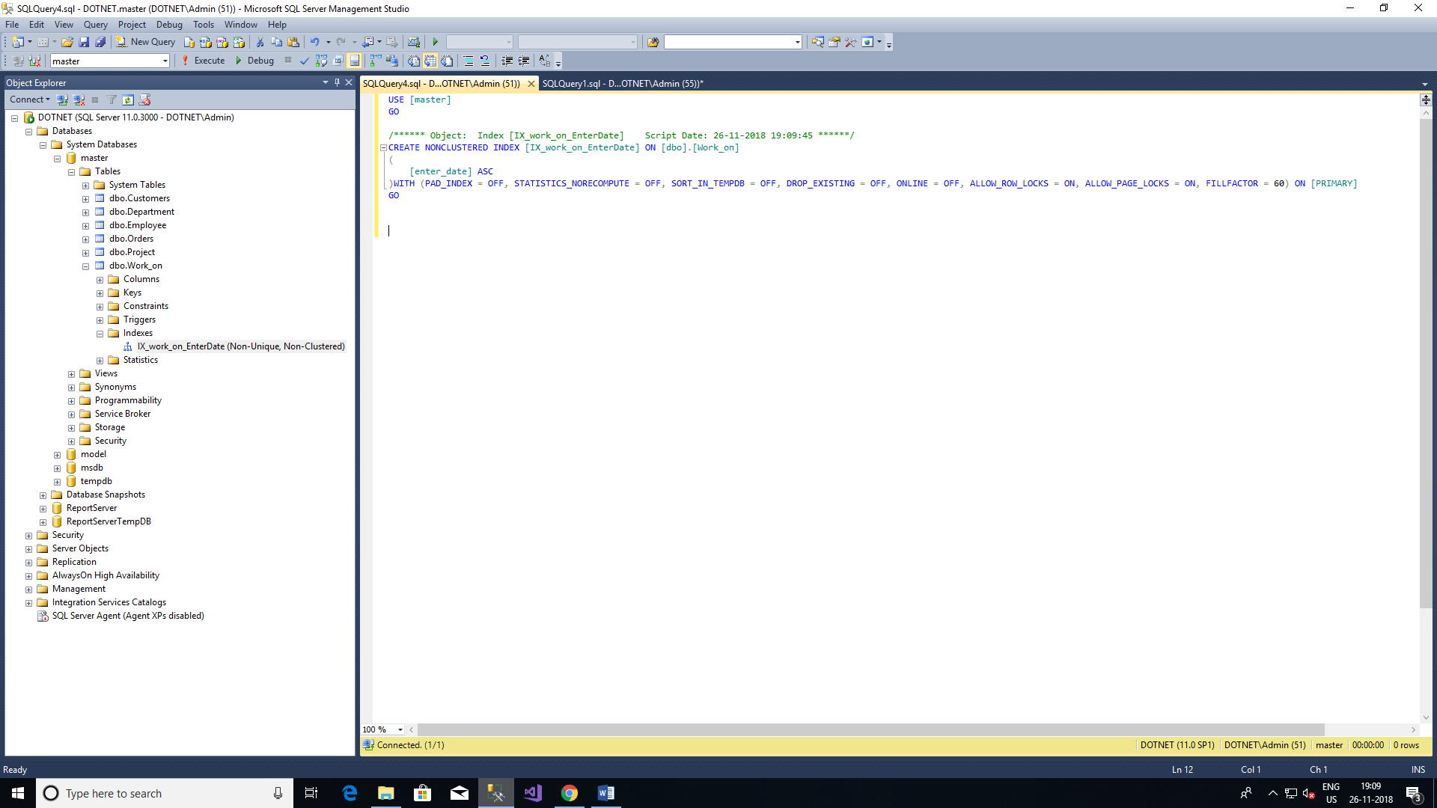

2. Create a unique composite index for the l_name and f_name columns of the employee table

CREATE UNIQUE INDEX IX_emp_Name ON dbo.Employee(emp_fname,emp_lname)